NOOR CULTURAL CENTRE
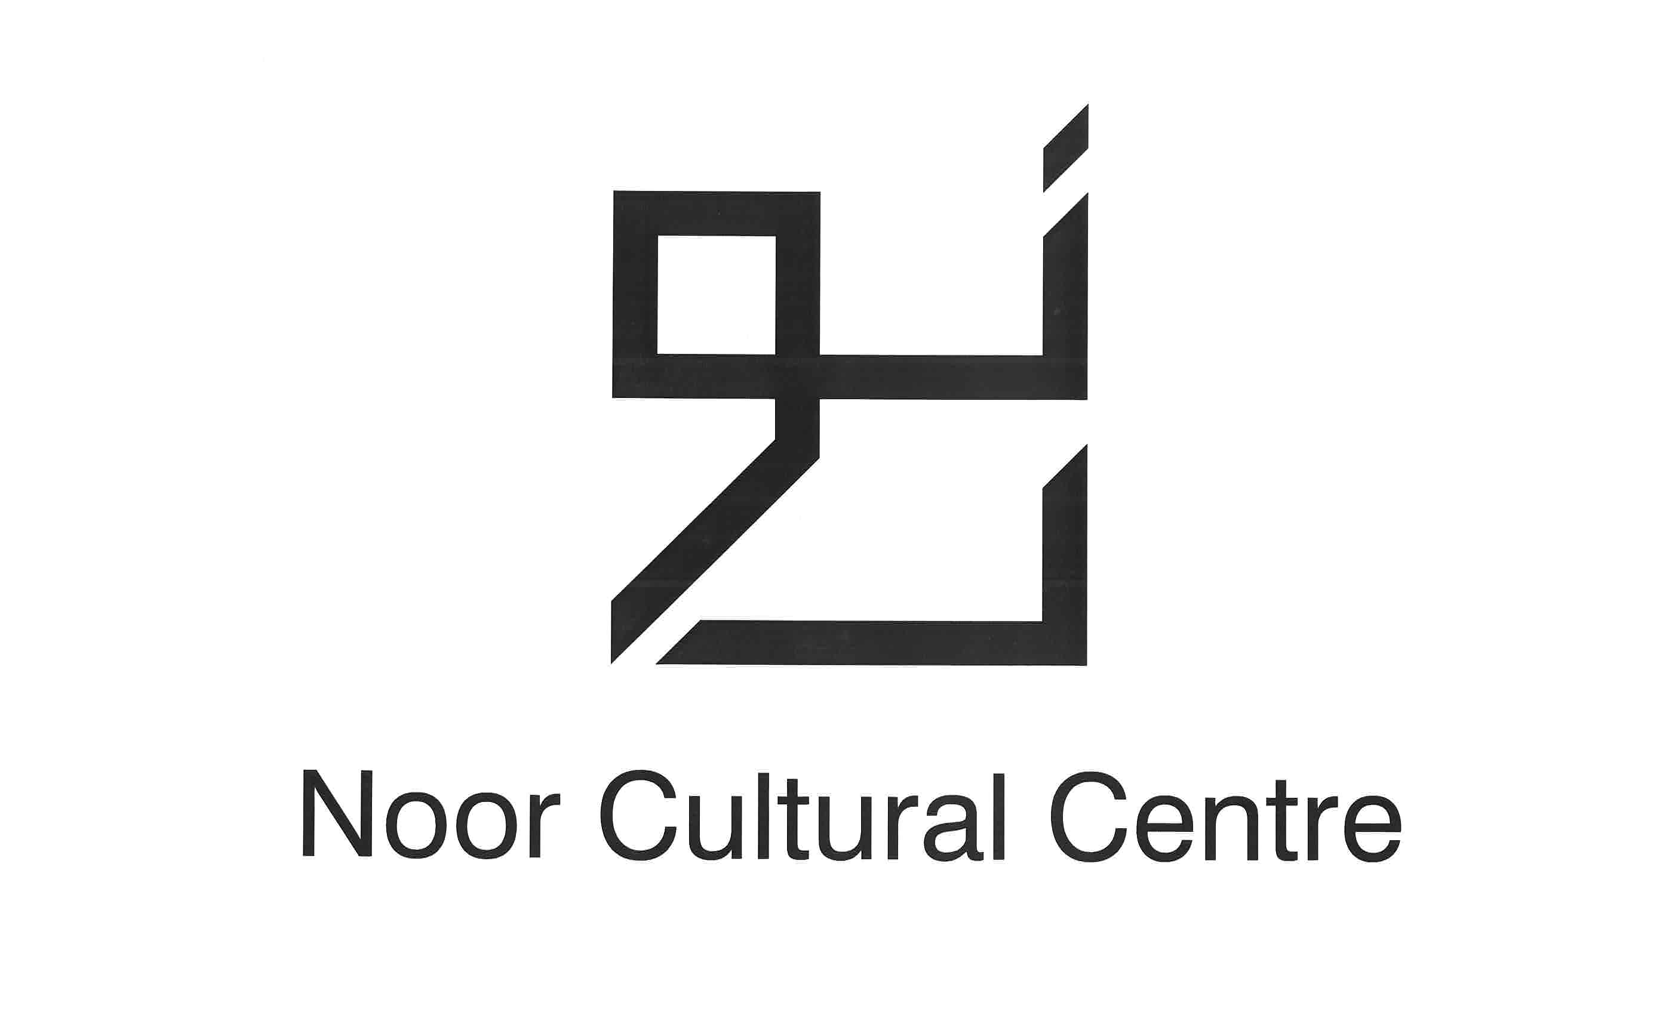
Noor Children’s Islamic School
Registration for 2009-2010

Child #1:

Name:________________________________________DOB:_____________________

Age & Grade at School:____________________________________________________

Medical Conditions or Allergies:_____________________________________________

_______________________________________________________________________

Child #2:

Name:________________________________________DOB:_____________________

Age & Grade at School:____________________________________________________

Medical Conditions or Allergies:_____________________________________________

_______________________________________________________________________

Parents/Legal Guardians:

Name(s):________________________________________________________________

Email Address(es):________________________________________________________

Home Phone:________________________ Cell Phone:_________________________

Cell Phone:_________________________

Emergency Contact Name and Phone : ________________________________________

________________________________________________________________________
I have read all of the attached program information and I agree to all the terms. I hereby grant consent for my child(ren) to participate in the Noor Children’s Islamic School and release the Noor Cultural Centre and its representatives from any liability arising as a result of any injuries or losses sustained by my child(ren) or me and any other family member of mine during the program.

_______________________________________________ _______________________
Parent’s Signature Date

The fee for the school year (approximately 30 classes) is $400 per child. Please check one of the following options for payment:
Cheque(s): One cheque for full program year ($400 per child) ______
Two cheques dated Oct. 4, 2009 and Jan. 4, 2010 ($200 per child) ______

Cheques should be made payable to Noor Cultural Centre.
Please submit registration form and cheque(s) by Friday, September 11th, 2009.
Registration forms and payment must be received in order for your child(ren) to start classes in October. Please note that space is limited in each group and classes will be filled with children in the order that registration forms and payments are received (no exceptions).
Completed registration forms and cheques should be mailed to:
Shameela Hoosen-Shakeel
992 Lockwood Circle
Newmarket, ON
L3X 1M1

